Career and Technology Studies 11/12
Trades, Manufacturing and Transport (TMT) Level II & III
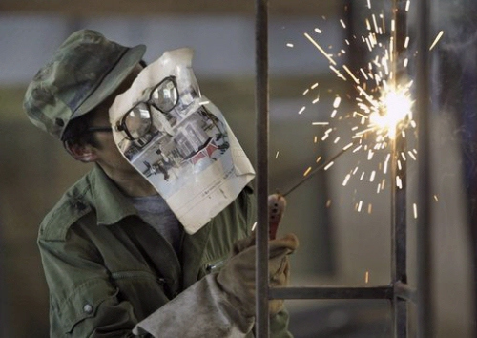
Fabrication 20 – is an intermediate level 5 credit course that strengthens the knowledge gained in Fabrication 10. By the end of the semester students should be able to safety, weld materials in multiple positions including flat and horizontal.
Course Website: www.halversoncts.com -
Course Text: Modern Welding
Course Instructors: Mr. Halverson
Contact Information: dean.halverson@wrsd.ca
- Fabrication2020 – Print Reading
Text: Joint and Weld Types ILM
50% Theory: Alberta Individual Learning Module
25% Tests: Exam
25 % Professionalism: Students ability to arrive on time, complete tasks safely and promptly, and work at their best ability.

- Fabrication2050 – Arc Welding 1
Text: Shielded Metal Arc Welding Part A
50% Practical: Lab work
20% Theory: Alberta Individual Learning Module
15% Tests: Exam
15 % Professionalism: Students ability to arrive on time, complete tasks safely and promptly, and work at their best ability.
Fit-ups: 6010 1/8” rod – butt/edge/corner
7018 1/8” rod – butt/lap/tee

- Fabrication2060 – Arc Welding 2
Text: Shielded Metal Arc Welding Part B
50% Practical: Lab work
20% Theory: Alberta Individual Learning Module
15% Tests: Exam
15 % Professionalism: Students ability to arrive on time, complete tasks safely and promptly, and work at their best ability.
Fit-ups (horizontal): 6010 1/8” rod – butt/edge/corner
7018 1/8” rod – butt/edge/corner/lap/tee

- Fabrication2070 – Gas Metal Arc Welding 1
Text: Modern Welding Ch 9 (pg.233-264, Q.1-22)
50% Practical: Lab work
20% Theory: Modern Welding
15% Tests: Exam
15 % Professionalism: Students ability to arrive on time, complete tasks safely and promptly, and work at their best ability.
Fit-ups (flat&horizontal): butt flat/butt horizontal/edge horizontal/corner horizontal/lap horizontal/tee-horizontal/6 pass tee horizontal

- Fabrication2160 – Custom Fabrication (Project)
70% Practical: Lab work
30 % Professionalism: Students ability to arrive on time, complete tasks safely and promptly, and work at their best ability.
Project: student designed project (drawing with dimensions must be submitted before project begins)

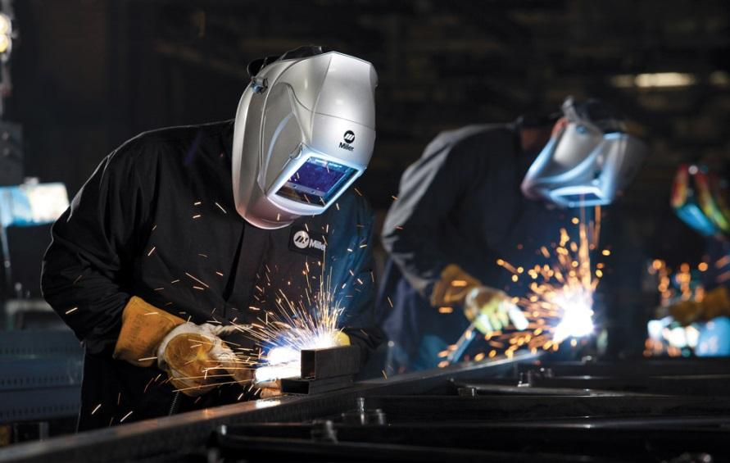

FAB2020: PRINT READING General Outcomes

The student will:
- Students develop basic skills in reading and interpreting working drawings to prepare a bill of materials and sequence of operations.
- apply fabrication processes and skills in a safe manner to produce a useful product.
- demonstrate basic competencies.

FAB2050: ARC WELDING 1
The student will:
- develop basic knowledge, skills and attitudes related to the operation and use of Shielded Metal Arc Welding (SMAW) equipment and accessories to make a variety of welds in the flat position.
- Prerequisite: FAB1050: Basic Electric Welding

FAB2060: ARC WELDING 2
The student will:
- identify appropriate electrodes by visually assessing a weld and making the necessary adjustments to improve weld quality while developing horizontal position welding skills.
Prerequisite: FAB2050: Arc Welding 1

FAB2070: GAS METAL ARC WELDING 1
The student will:
- develop an understanding of the advantages and disadvantages of Gas Metal Arc Welding (GMAW) processes, and they gain experience using GMAW processes by performing flat, horizontal and vertical fillet welds and flat groove welds.
Prerequisite: FAB1048: Semi-automated/Automated Welding

Students are evaluated based upon the following criteria:
1. Work Skills – Basic Competencies
- Adhere to all health, safety and operating procedures.
- Prompt and prepared for class; makes productive use of time.
- Work well with others; promote safety and assist others with job tasks.
- Fulfill housekeeping, tool maintenance and product storage duties.
2. Planning and Management – Design Process
- Select or design a project that reflects knowledge, skill and ability.
- Complete a detailed draft/design (top, side, front views) of the project using
appropriate medium, scale and measurements.
- Complete material estimate (cost) sheet, reflecting appropriate material selection
and quantity of materials required (including waste).
- Complete construction notes including task planning, tools and materials
required, as well as any additional information.
- Complete cut diagram reflecting minimal wastage of material.
3. Construction Techniques – Equipment and Materials
- Access and utilize resources and tools with increasing confidence and precision.
- Utilize pre-job planning to identify and eliminate hazards.
- Ensure proper training, qualification and certification prior to all work.
- Assist others with instructions, tool selection and material handling.
4. Knowledge, Skills and Abilities - Tasks and Performance
- Complete relevant exam and/or satisfy content requirements (theory) for
corresponding modules.
- Establish and adhere to goals and guidelines for the completion of all work; use
class time effectively.
- Anticipate problems and accept challenges – think critically and creatively!
- Uses appropriate language, tools, materials and processes at all times.
- Show me what you know – always demonstrate best work practices based upon
your knowledge, skills and abilities.
5. Project Presentation – Construction and Assembly
- Cuts and squares stock according to plan.
- All joints are tight fitting; project has been sanded uniformly and finished
according to planning process and standards set.
- Student self-evaluation completed.
- Suggest possible improvements to the design and construction process.
- Describes the purpose of the project.
Assessment varies for each module. A minimum of 50% is required for credit in the module. There is no cumulative final exam at the end of the semester. Your final report card mark will display each of the modules you have taken and the grade received.

Module Stream Selection
PREREQUISITE MODULES (Level I - Mandatory Completion)
- Basic Tools and Materials FAB 1010
- Oxyfuel welding FAB 1040
- Semi-automated Welding FAB 1048
- Basic Electric Welding FAB 1050
- Sheet Fabrication FAB 1090
- Fabrication Principles FAB 1100
- Principles of Machining FAB 1130
*Students who demonstrate exemplary effort, understanding and achievement may also
qualify for an additional credit by fulfilling the requirements for FAB 1910: Project A

FABRICATION STUDIES (Level II - Prerequisites required)
- Oxyfuel Welding FAB 2030
- Thermal Cutting FAB 2040
- Flux Core Welding FAB 2048
- Arc Welding I FAB 2050
- Arc Welding II FAB 2060
- Gas Metal Arc Welding FAB 2070
- Sheet Fabrication II FAB 2090
- Precision Turning I FAB 2130
- Precision Milling I FAB 2140
*Students who demonstrate exemplary effort, understanding and achievement may also
qualify for an additional credit by fulfilling the requirements for FAB 2910: Project B or
FAB 2920: Project C.

FABRICATION STUDIES (Level III - Specialization)
- Oxyfuel Welding FAB 2030
- Thermal Cutting FAB 2040
- Flux Core Welding FAB 2048
- Arc Welding I FAB 2050
- Arc Welding II FAB 2060
- Gas Metal Arc Welding FAB 2070
- Sheet Fabrication II FAB 2090
- Precision Turning I FAB 2130
- Precision Milling I FAB 2140
*Students who demonstrate exemplary effort, understanding and achievement may also
qualify for an additional credit by fulfilling the requirements for FAB 3910: Project D or
FAB 3920: Project E.

Fabrication Studies Shop Class Rules

All shop students must wear CSA Safety Glasses while they are in the shop. There will be no exceptions. Parents will be contacted if students do not comply with this rule.

Fabrication students must wear coveralls, which are suitable for use in a welding shop. These must be free of all flammable materials and contaminants.
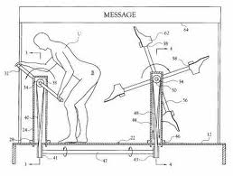
All students must maintain a portfolio, which contains the up to date information handouts and review questions provided by your instructor.

All students must abide by the FMHS attendance policy; this means that lates and absences will be tracked and recorded by your instructor.

Students must come prepared to work in the shop and in the classroom, and they must be in the classroom when attendance is taken in order to avoid be recorded as late.

The students who come late, or without their portfolio will complete the cleanup of the common areas.

CTS Safety Contract

Safety education is a major part of CTS courses. The following document has been designed to encourage students to comply with the safety rules, and procedures used in the Fabrication Shop at Frank Maddock High School.
Student
Initial
I know that I may not use any tools/power tools without proper authorization from my instructor.
I know I must disconnect electricity before servicing electrical appliances.
I have been instructed how to plug and unplug the electrical equipment.
I have been instructed on the importance of eye protection and I know that I must use eye protection at all times while I am in the shop.
I know that when I am in doubt, I must consult with my teacher on how to use or store equipment.
I know how to protect my eyes from the hazards in the Welding Shop.
I will wear eye protection when I am working with power/dangerous tools.
I know that I will be working with very high temperatures and I know how to keep from being burned.
I have been instructed on how to lift heavy objects property.
I am aware of the danger of horseplay in the shop.
The shop has a First Aid Station; I know its location.
I know what type of clothing is required in the shop area.
I know that I will be working with large and powerful power tools. I will ask my instructor for help using tools I am unsure of.
I will not use shop tools or equipment to create illegal objects.
I will not use shop tools or equipment to create objects, which violate community standards.
If I break these rules I understand that my parents may be notified and I may be withdrawn from the course.

FMHS Fabrication Shop is a Cell Phone Free Shop. Due to Safety Reasons (Distractions from phone/Damage that could happen to screen/phone) cell phones are not permitted in the shop. Please keep cell phones in your Locker during Fabrication class. FMHS is not responsible for any damage/theft that could occur to cell phones that are left unattended in the Fabrication classroom.
Student Signature _______________________

Parent / Guardian Signature________________________

Date___________________________

